
human computer interaction
COIS12036

Assessment 2


Anshul Bairy | 12266750
CQUniversity Rockhampton North, Australia
Unit Coordinator: Ayub Bokani
Unit Tutor: Tek Awasthi
Term 1, 2026
Due Date: Week 7

Contents
Section 1: Introduction and Motivation 2
ResConnect: A Unified Communication Platform for University Residential Leaders 2
The Problem 2
The Proposed Solution 2
Section 2: User Research and Personas 3
2.1. User Research 3
2.2. Persona 1: The Residential Leader 3
2.3. Persona 2: The First-Year Resident 5
Section 3: Scenario Design and Hierarchical Task Analysis 6
3.1. Scenario 1: Filling a Duty Report After Rounds (Reece) 6
3.2. Scenario 2: Creating and Promoting a College Event (Reece) 7
3.3 Scenario 3: Discovering an Event and Reporting a Maintenance Issue (Kuni) 8
Section 4: Paper Wireframes 9
Wireframe 1: Duty Report Submission Screen (Scenario 1: Reece) 9
Wireframe 2: Event Creation and Kanban Status Screen (Scenario 2: Reece) 10
Wireframe 3: Resident Feed + Issue Report Screen (Scenario 3: Kunihiro) 10
Section 5: Digital Wireframes 11
Interface Screenshot 11
References 12

Section 1: Introduction and Motivation

ResConnect: A Unified Communication Platform for University Residential Leaders
Residential leaders (RLs) at university colleges are responsible for pastoral care, after-hours reception duties, duty rounds, event coordination, and shift handovers across an entire residential precinct. Despite the complexity of this role, RLs currently rely on a scattered collection of consumer apps and manual processes to get the job done. At a regional campus like CQUniversity Rockhampton, a single RL shift might involve Facebook Messenger for coordinating handovers, the Safety and Cultures app for filing duty reports, Instagram and printed posters for event promotion, Google Drive for sharing risk assessments, Gmail for formal communication, and a physical duty phone that gets passed hand-to-hand between shifts. There is no single system that ties any of this together (Mark, Gudith & Klocke 2008).

The Problem
This fragmentation creates real, recurring failures. The Safety and Cultures app regularly fails to send duty reports to the RLT mailing list, forcing RLs to resubmit the same report multiple times and hope it eventually goes through. Event promotion requires creating content across Facebook, Instagram, printed posters, and house group chats separately, with no way to confirm who has actually seen the information. Shift handovers on weekends depend on RLs texting each other on Messenger to arrange a physical meetup at someone’s room or the dining hall, and if schedules don’t line up, the handover simply doesn’t happen properly. There is no searchable record of past duty reports, handover notes, or event outcomes. If something happened two weeks ago, the only way to find out is scrolling through a group chat (Nardi, Whittaker & Bradner 2000).
For residents, this situation is just as broken from the other side. International students who weren’t added to the right group chats during the move-in miss event announcements entirely. Printed posters in common areas advertise events that have already passed. Residents who want to report a minor issue like a noise complaint or a broken fixture don’t have a low-friction way to do it without messaging their RL directly on Facebook or raise a maintenance request on CQU Starrrez portal, which feels like an overreaction for small concerns.

The Proposed Solution
ResConnect is a purpose-built web app designed to replace this patchwork with a single platform built around how RLs actually work. Its core features include a structured duty report system with send confirmation, a digital shift handover log that records what happened and who read it, an event dashboard with built-in RSVP tracking and promotion tools, and a resident-facing feed where announcements, events, and welfare check-in options all live in one place. The goal is not to add another app to the pile but to replace the pile entirely (Grudin 1994).
From an entrepreneurial perspective, no dedicated product currently exists for this specific use case in the Australian university residential market. The closest alternatives are generic workplace tools like Slack or Microsoft Teams, which require significant setup and aren’t designed for the pastoral care and community engagement workflows that define residential life.
x

Section 2: User Research and Personas

2.1. User Research
University residential colleges in regional Australia house a diverse mix of domestic and international students across multiple year levels. At a campus like CQUniversity Rockhampton, the residential precinct consists of several separate buildings (referred to as “houses”), each holding around 40 residents with shared corridors, communal bathrooms, common areas, and self-catered options. The demographic breakdown skews first-year heavy (roughly 40%), with a notable international cohort (around 30%) and a smaller group of returning senior residents. By second or third year, many residents move off campus due to rising rent costs and established social circles, meaning population refreshes significantly each intake (Wode 2018).
Two distinct user groups shape how ResConnect needs to function. Residential Leaders are students who have voluntarily taken on a pastoral care and coordination role on top of full-time study. They’re motivated by a mix of leadership identity, community connection, and financial incentives like rent bursaries. Their daily workflow is shaped by reactive, interrupt-driven tasks that jumps between digital and physical channels with no connecting thread. First-year residents, particularly international students, sit on the other end. They’re navigating a major life transition while managing study, work, and social adjustment simultaneously. Their engagement with college life depends almost entirely on whether information reaches them passively. If they have to go looking for it, they probably won’t (Krause & Coates 2008).

2.2. Persona 1: The Residential Leader
Persona 1
Name | Reece Williams
Age | 21
Role | Residential Leader at a regional university college, managing a 46-person house
Study | 3rd year Bachelor of IT, full-time, 4 units this term
RL Tenure | 18 months
Tech Use | Facebook Messenger, Instagram, Gmail, Google Drive, Safety and Cultures app, StarRez portal
Background
Reece took the RL role because he’s been drawn to leadership his whole life and genuinely likes helping people settle into college. The rent bursary helps too. After 18 months, the job itself isn’t what frustrates him. He knows how to run duty rounds, how to sit down with a resident who’s struggling, how to pitch an event at the Monday 6.30pm RL meeting and carry it through the execution. What drains him is the cognitive overhead of keeping everything organized across tools that were never designed for this job.
On a given shift, Reece might handle a pastoral care conversation with a homesick first-year, file a duty report, coordinate a physical handoff of the duty phone, respond to a maintenance request, and promote an upcoming event. Each of those tasks lives in a different app, and none of them carry state across to the next shift. He’s essentially rebuilding context from scratch every time he picks up the duty phone, because the previous RL’s shift only exists as chat thread or a report that may or may not have landed. The mental load of tracking what happened, what’s pending, and what needs follow-up sits entirely in his head (Wickens 2008).
The event planning cycle is where this hits hardest. Reece proposes and event, gets approval from the Residential Life Coordinator, writes a risk assessment, designs a flyer, and posts it across multiple platforms, prints physical copies for notice boards shares it to house group chats, and then does verbal reminders at dinner for a week straight. All of that coordination happens manually, and there’s no way to see at a glance whether the event is on track or how many people are actually coming.
Goals
- Have one place where duty rosters, reports, meeting minutes, and event status all live together.
- Reduce the cognitive load of context-switching between platforms during a single shift.
- Make a shift handovers structured and recorded so nothing gets lost between RLs.
- Cut the event promotion workflow down to a single creation point instead of five separate channels.
HCI Challenges
Challenge | Impact on Reece | What the design needs to do
Cognitive overload | Rebuilds context from scratch every shift because nothing carries over | Persistent dashboard showing current shift status, recent reports, and pending tasks
No confirmation feedback | Submits duty reports without knowing if they were received | Visible send confirmation with retry option and local draft save
Manual event tracking | Can’t see at a glance if risk assessment is approved, supplies are ordered, or RSVPs are in | Kanban-style event timeline showing task status and days remaining
Fragmented meeting follow-ups | Monday meeting decisions live in printed notes that aren’t searchable | Digital minutes log linked to action items and responsible RLs
Handover information loss | Incoming RL has no structured way to know what happened on the previous shift | Timestamped handover log with read receipts.

2.3. Persona 2: The First-Year Resident
Persona 2
Name | Kunihiro Shimoyushaki
Age | 19
Role | First-year resident, international student
Study | 1st year Bachelor of Engineering, full-time
Living Situation | First time in Australia, first time away from family, shared corridor house
Tech Use | Instagram, Line, WhatsApp, university email (rarely checked)
Background
Kuni moved to Rockhampton from Japan three months ago. He's managing a full engineering courseload, working 20 hours a week at a local cafe to cover his rent, and still figuring out how Australian university life works. Between classes, shifts, and assignments, his capacity to actively seek out information is basically zero. He sees event posts when they come across his feed, but by the time he thinks about going, the event has either already happened or he's got a work shift that clashes.
The social side is harder to pin down. Kuni knows who his RL is and would probably reach out if something was seriously wrong, but for smaller things (a noisy neighbour, a broken shower head, a question about how laundry credits work) he doesn't have a comfortable way to ask without it feeling like a formal escalation. He's also not plugged into the informal communication channels that most domestic students take for granted. Nobody walked him through what group chats to join during move-in week, and he didn't know to ask. The result is that Kuni's experience of college life is mostly passive. Things happen around him and he picks up fragments through word of mouth at dinner, but he's rarely in the loop before something happens (Sin & Kim 2013).
Goals
- Know what's happening on campus without having to check five different platforms
- Be able to RSVP to an event quickly and see if other people he knows are going
- Have a low-pressure way to flag small issues to his RL without it feeling like a formal complaint
HCI Challenges
Challenge | Impact on Kuni | What the design needs to do
Passive information gap | Misses announcements because he’s not in the right channels and doesn’t seek them out. | Push notifications for events and announcements to one central feed.
Language and cognitive load | English is his second language; long text-heavy posts are hard to parse after a full day of study and work | Visual-first UI with icons, card layouts, and minimal text per element
Reporting friction | Small issues go unreported because the only option feels too personal or too formal | Anonymous or low-friction “I need help” button that doesn’t require writing a message
Time poverty | Works 20 hours a week on top of full-time study, no spare time to browse for information | Mobile-first design, thumb-reachable actions, 3-second scan-and-act pattern
Social proof gap | Won’t commit to an event unless he knows someone else is going | Visible RSVP count and “friends attending” indicator on event cards
x

Section 3: Scenario Design and Hierarchical Task Analysis
Each scenario below describes a specific interaction with ResConnect, mapped to one of the two personas from Section 2. Hierarchical Task Analysis (HTA) was chosen as the modelling method because it breaks complex, multi-step workflows into a clear parent-child task structure with explicit plans governing when subtasks execute (Stanton 2006). This is particularly suited to ResConnect because the task RLs and residents perform are procedural and condition-dependent (for example, a duty report can be only submitted after rounds are completed, and an event can only be promoted after the Residential Life Coordinator has approved it).

3.1. Scenario 1: Filling a Duty Report After Rounds (Reece)
Reece has just finished his Friday night duty rounds across the residential precinct. He walked through every house, checked the common areas, spoke to a few residents hanging out in the JCR, and found a broken window latch in House 3 that needs maintenance. He now needs to file his duty report to the RLT mailing list before he sleeps so the management team and the next RL on shift both have a record of what happened tonight.
In ResConnect, Reece opens the dashboard on his phone and taps “New Duty Report”. The app loads a pre-structured template with sections for each house, already populated with the building names he’s responsible for. He taps through each house, enters his round observations, and flags the maintenance issue in House 3 by selecting “Maintenance Required” from dropdown and typing a one-line description. He hits submit. A green confirmation banner appears at the top of the screen with a timestamp, confirming the report was delivered to the RLT list. If the send had failed, ResConnect would save the report locally and retry automatically, notifying Reece when it goes through. The submitted report is now visible in the shift handover log for the next RL (Tang & Carpendale 2007).
HTA: File a Duty Report
- File a duty report after completing rounds
  - Open ResConnect dashboard
  - Select “New Duty Report”
  - Complete the report template
  - Review pre-populated house list
  - Enter observations for each house
  - Flag maintenance issues (select category + type description)
  - Submit the report
  - Tap “Submit to RLT list”
  - Receive sends confirmation (green banner + timestamp)
  - If send fails -> report saves locally -> auto-retry with notification
  - Report appears in shift handover log for next RL
Plan 0: Do 1, then 2, then 3, then 4, then 5.
Plan 3: Do 3.1, then 3.2 for each house. If a house has an issue do 3.3.
Plan 4: Do 4.1, then 4.2, if delivery fails, do 4.3.

3.2. Scenario 2: Creating and Promoting a College Event (Reece)
Reece pitched a Pancake Night at last Monday’s 6:30pm RL meeting and got a verbal approval from the team. Now he needs a formal sign-off from the Residential Life Coordinator (RLS), a completed risk assessment on file, and promotional material published out across the residence before Friday.
In ResConnect, Reece opens the Event Dashboard and taps “New Event”. He fills in the event name, date, time, and location, writes a short description, and uploads his risk assessment as a PDF. The app sends and approval request notification to the RLC. When the RLC signs off (which shows up as a green tick on the event card), Reece moves to promotion. He selects a built-in poster template, adds the event image, previews the flyer, and hits “Publish”. ResConnect pushes the event to the resident feed as a card with RSVP enabled, generates a shareable link Reece can drop into house group chats, and make the flyer available for download so he can print copies for notice boards. On his Event Dashboard, a Kanban-style timeline shows him the vent’s status: risk assessment approved, supplies requested, 3 days until the event, and a live RSVP count updating as residents respond (Anderson 2010).
HTA: Create and Promote an Event
- Create and promote a college event
  - Open Event Dashboard
  - Create new event
  - Enter event details (name, date, time, location)
  - Write event description
  - Upload risk assessment PDF
  - Request RLC approval
  - App sends notification to RLC
  - Wait for approval status update
  - Receive green tick confirmation on event card
  - Design promotional material
  - Select poster template
  - Add event image and details
  - Preview flyer
  - Publish and distribution
  - Tap “Publish” to push event card to resident feed
  - Copy shareable link for house group chats
  - Download flyer PDF for printing
  - Track engagement on Kanban timeline
  - Monitor RSVP count on event card
  - View event status (approval, supplies, days remaining)
Plan 0: Do 1, then 2, then 3. When approved, do 4, then 5, then 6.
Plan 2: Do 2.1, then 2,2, then 2.3.
Plan 3: Do 3.1, then, 3.2. Upon update, do 3.3.
Plan 4: Do 4.1, then 4.2, then 4.3.
Plan 5: Do 5.1, then 5.2 and 5.3 can be done in any order.
Plan 6: Do 6.1 and 6.2 as needed (ongoing monitoring).

3.3 Scenario 3: Discovering an Event and Reporting a Maintenance Issue (Kuni)
Kuni gets back to his room after long Wednesday of lectures and a four-hour café shift. He’s got a 9am class tomorrow and wants to quickly check if anything is happening this week before he sleeps. He also noticed the shower head in the common bathroom has been dripping for three days and wants to flag it without having to message his RL directly on Facebook about something that feels too small to bring up personally.
In ResConnect, Kuni opens the app on his phone. The resident feed shows two event cards for the week: Pancake Night on Thursday and a Study Session on Saturday. Each card has the event name, time, location, and an RSVP count. He sees that 14 people have RSVPed for Pancake Night, including two people from his houses he recognises, so he taps “I’m going”. The app confirms his RSVP with a quick tick animation. Then he taps the “Report Issue” button at the bottom of the feed, selects “Maintenance” from category list, picks “Bathroom” and “House 4” as the location, and types “shower head leaking”. He doesn’t need to enter his name. The report goes to the RL on duty and gets logged for the maintenance team automatically (Parasuraman, Sheridan & Wickens 2000).
HTA: Discover Events and Report an Issue
- Discover weekly events and report a maintenance issue
1. Open ResConnect on mobile
2. Browse the resident feed
2.1 View event cards for the current week
2.2 Check RSVP count and “friends attending” list
3. RSVP to an event
3.1 Tap “I’m going” on event card
3.2 Receive RSVP confirmation animation
4. Report a maintenance issue
4.1 Tap “Report Issue” button
4.2 Select issue category (Maintenance)
4.3 Select location (Bathroom, House 4)
4.4 Type short description
4.5 Submit (no name required)
5. Submit routes to RL on duty and maintenance log
Plan 0: Do 1, then 2. If interested in an event, do 3. If there’s an issue to report, do 4. System does 5 automatically.
Plan 2: Do 2.1, then 2.2 for any event of interest.
Plan 3: Do 3.1, then 3.2.
Plan 4: Do 4.1, then 4.2, then 4.3, then 4.4, then 4.5.
x

Section 4: Paper Wireframes
Each wireframe below corresponds to one of the three scenarios from Section 3. These are low-fidelity sketches that show screen layout, key UI elements, and interaction flow. They don’t need to be pixel-perfect; the purpose is to demonstrate how the interface supports each user’s task.

Wireframe 1: Duty Report Submission Screen (Scenario 1: Reece)
Screen: Mobile ResConnect Dashboard New Duty Report
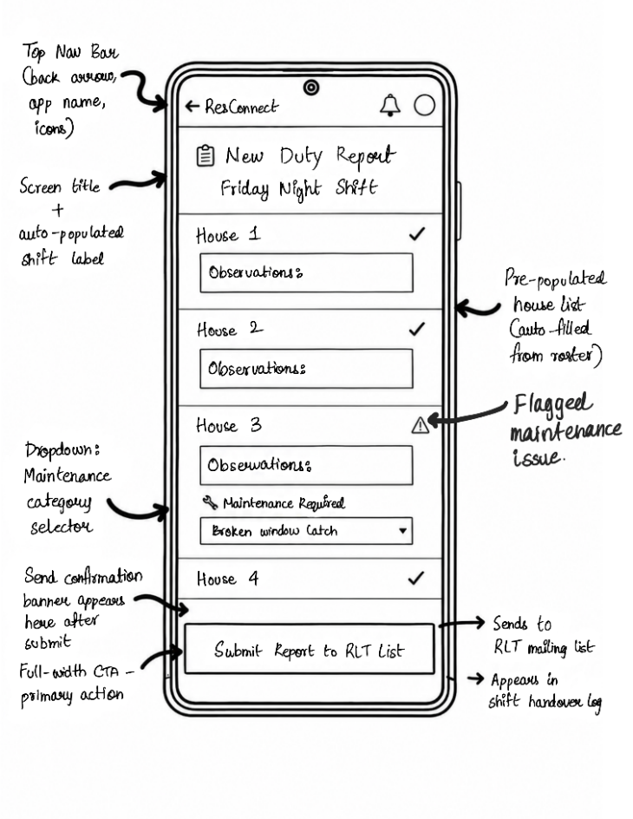 | Design Rationale:  This wireframe covers Reece filling his Friday night duty report. Because his main issue from Section 2 is cognitive overload, the form automatically fills in his house roster so he doesn’t have to type it out. It also adds a clear confirmation banner and retry logic when the submit button is pressed. This provides proper system feedback so he actually knows the report reached the management team.

Wireframe 2: Event Creation and Kanban Status Screen (Scenario 2: Reece)
Screen: Mobile ResConnect New Duty Report
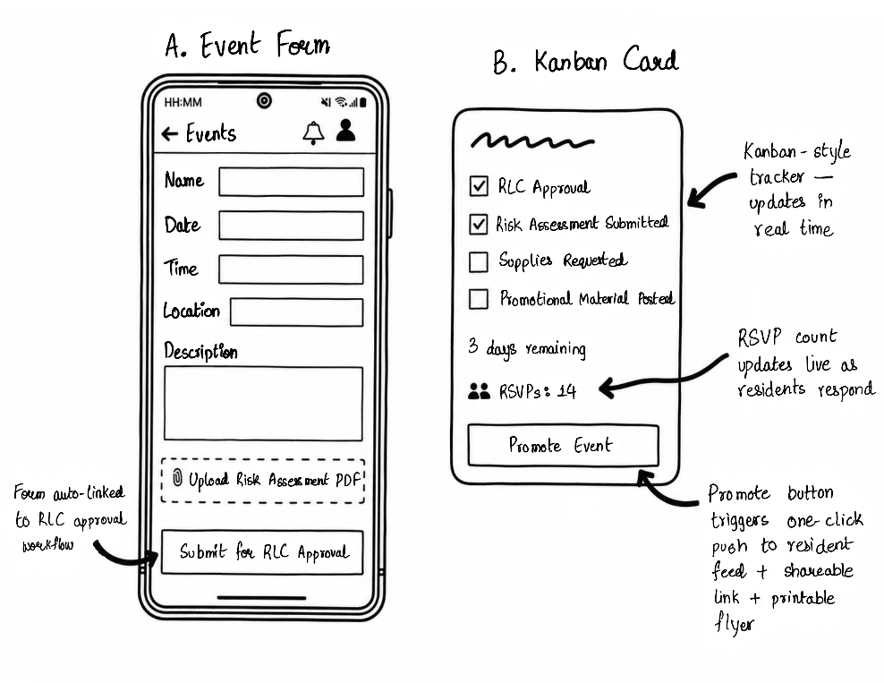 | Design Rationale:  This shows how Reece creates and tracks a college event. Instead of jumping between five different apps to check risk assessments and flyers, everything sits in a single Kanban-style tracker. This cuts down his coordination overhead. I also added a live RSVP counter so he can see exactly how many residents are coming without having to guess.

Wireframe 3: Resident Feed + Issue Report Screen (Scenario 3: Kunihiro)
Screen: Mobile ResConnect Resident Feed RSVP Report Issue Form
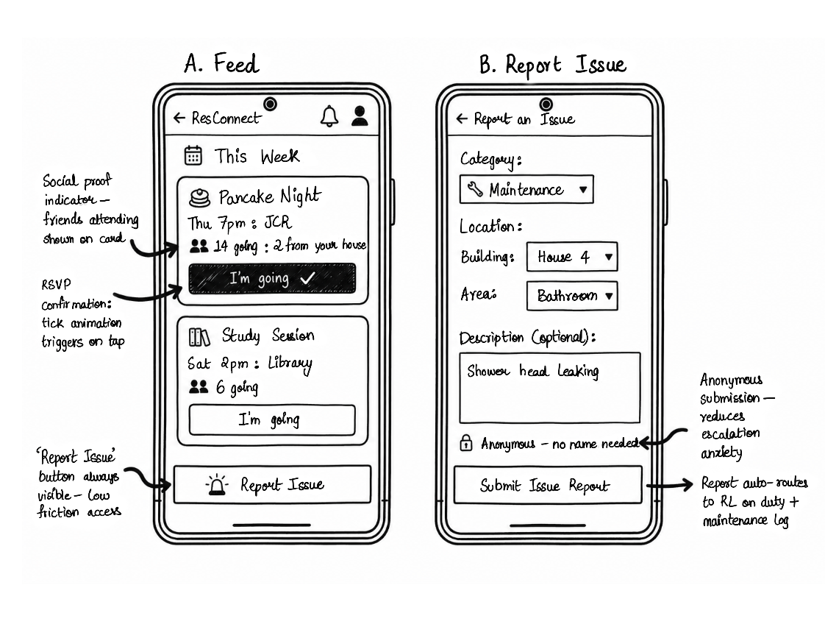
Design Rationale:
This wireframe maps to Kuni’s resident feed. Since he struggles to find information actively, the event cards bring everything to him. The design uses social proof (Cialdini 2001) by showing if his friends are going to encourage him to RSVP. There is also a sticky, anonymous “Report Issue” button at the bottom. This means he can flag maintenance issues without the social anxiety of having to message his RL directly.
x

Section 5: Digital Wireframes
This digital wireframe prototype was developed using HTML5 and CSS3, demonstrating the proposed layout and visual hierarchy for the core Resident Feed (Scenario 3).
The decision to prototype in code rather than a static design tool (like Figma) allows for an accurate representation of responsive scaling and native browser rendering, acting as a foundational step toward the High-Fidelity functional prototype required in Assessment 3.

Interface Screenshot
HCI Principles & Design Decisions Demonstrated:  - Cognitive Load Reduction (Wickens 2008):  The UI uses a card-based layout. Because Kunihiro is a time-poor, cognitively overloaded first-year student, breaking information into visual chunks makes the feed much easier to scan. I kept the text short and used FontAwesome icons to show meaning quickly. I also used the official CQUniversity brand colours (Deep Green: #1E4041 and Lime Green: #C7DC5D) so the app feels like it belongs to Capricornia College. The clean white background with dark green text makes it readable without being overwhelming.  - Social Proof & Motivation (Cialdini 2001):  The user research showed that residents usually wait to see if their friends are going before, they commit to an event. To fix this, I added a social proof section on every event card that shows exactly how many people are going, like “14 going, 2 from your house”, along with smaller avatar bubbles. This uses social influence to make residents feel more comfortable about clicking RSVP. | 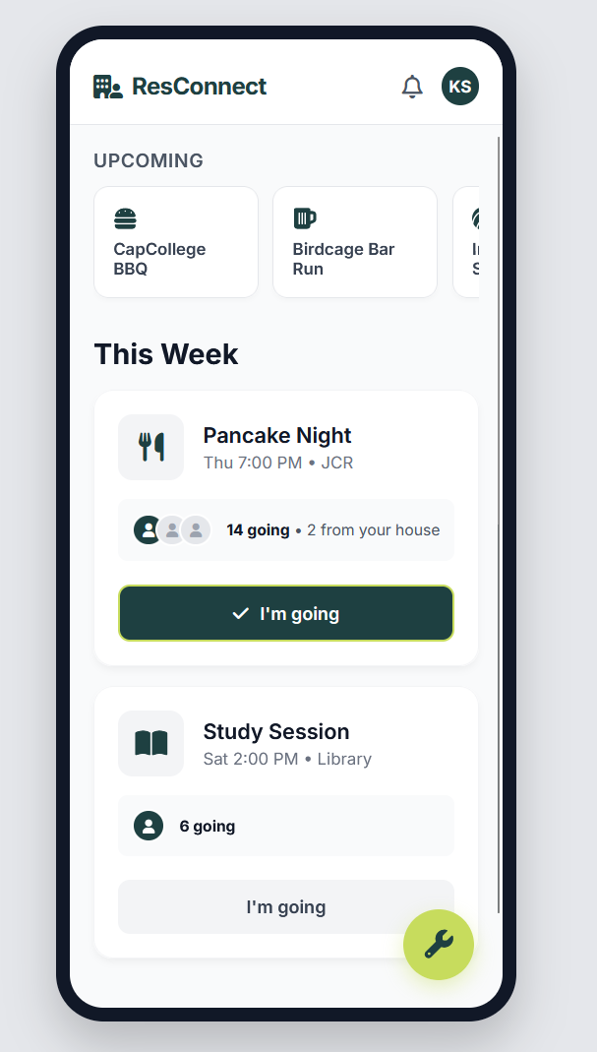
- Flexibility and Efficiency of Use (Nielsen 1994):
The “Report Issue” tool is built as a Floating Action Button (FAB) anchored to the bottom right. Instead of hiding the maintenance reporting tool in a menu, it stays on the screen where the user’s thumb naturally rests. I styled the FAB in the high-contrast CQU Lime Green (#C7DC5D) so it stands out against the white cards. This removes navigation friction and gives anxious residents an easy, low-pressure way to ask for help without having to write a formal message.

- Visibility of System Status (Nielsen 1994):
When a user clicks RSVP, the button physically changes. It goes from standard grey background to the active CQU Deep Green with a Lime Green border and a checkmark icon. This gives the user instant visual feedback so they know the system actually registered their click.

References
Anderson, DJ 2010, Kanban: successful evolutionary change for your technology business, Blue Hole Press, Sequim, WA.
Cialdini, RB 2001, Influence: science and practice, 4th edn, Allyn and Bacon, Boston.
Grudin, J 1994, 'Groupware and social dynamics: eight challenges for developers', Communications of the ACM, vol. 37, no. 1, pp. 92-105. DOI: 10.1145/175222.175230
Krause, KL & Coates, H 2008, 'Students' engagement in first-year university', Assessment and Evaluation in Higher Education, vol. 33, no. 5, pp. 493-505. DOI: 10.1080/02602930701698892
Mark, G, Gudith, D & Klocke, U 2008, 'The cost of interrupted work: more speed and stress', Proceedings of the SIGCHI Conference on Human Factors in Computing Systems, pp. 107-110. DOI: 10.1145/1357054.1357072
Nardi, BA, Whittaker, S & Bradner, E 2000, 'Interaction and outeraction: instant messaging in action', Proceedings of the 2000 ACM conference on Computer supported cooperative work, pp. 79-88. DOI: 10.1145/358916.358975
Nielsen, J 1994, Usability engineering, Academic Press, Cambridge, MA.
Parasuraman, R, Sheridan, TB & Wickens, CD 2000, 'A model for types and levels of human interaction with automation', IEEE Transactions on Systems, Man, and Cybernetics-Part A: Systems and Humans, vol. 30, no. 3, pp. 286-297. DOI: 10.1109/3468.844354
Sin, SCJ & Kim, KS 2013, 'International students' everyday life information seeking: the informational value of social networking sites', Library & Information Science Research, vol. 35, no. 2, pp. 107-116. DOI: 10.1016/j.lisr.2012.11.006
Stanton, NA 2006, 'Hierarchical task analysis: developments, applications, and extensions', Applied Ergonomics, vol. 37, no. 1, pp. 55-79. DOI: 10.1016/j.apergo.2005.06.003
Tang, C & Carpendale, S 2007, 'An observational study of information flow during nurses’ shift exchange', Proceedings of the SIGCHI Conference on Human Factors in Computing Systems, pp. 409-418. DOI: 10.1145/1240624.1240661
Wickens, CD 2008, 'Multiple resources and mental workload', Human Factors, vol. 50, no. 3, pp. 449-455. DOI: 10.1518/001872008X288394
Wode, J 2018, 'Identifying the factors that motivate students to choose off-campus housing', Journal of College and University Student Housing, vol. 44, no. 3, pp. 10-29.

